|  |  |
| --- | --- |
| **­** | **MINISTRY OF EDUCATION AND TRAINING** |

**FPT UNIVERSITY**

|  |  |
| --- | --- |
| **Report 1** | |
| **Parking Guidance System Solution** | |
| **Group 1** | |
| **Group members** | Trần Nguyễn Minh Trung – Team Leader – SE61496  Bùi Phú Hiệp – Team Member – SE61438  Nguyễn Đỗ Phương Huy – Team Member – SE61358 |
| **Supervisor** | Nguyễn Đức Lợi |
| **Ext. Supervisor** | N/A |
| **Capstone Project Code** | PGSS |

- Ho Chi Minh City, Jan, 2017

*This page is intentionally left blank*

# Table of Contents

Table of Contents 1

List of Tables 2

List of Figures 2

Definitions, Acronyms and Abbreviations 2

A. Introduction 3

1. Project Information 3

2. Introduction 3

3. Current Situation 3

3.1. Indoor parking area 4

3.2. Outdoor parking area 5

3.3. Traditional PGS 6

4. Problem Definition 7

5. Proposed Solution 8

5.1. Feature functions 8

5.1.1. Parking Guidance System 8

5.1.2. Mobile app 8

5.2. Advantages 8

5.3. Disadvantages 8

6. Functional Requirements 9

7. Roles and Responsibilities 9

8. Conclusion 10

# List of Tables

Table 1: Definitions, Acronyms and Abbreviations 4

Table 2: Roles and Responsibilities 12

# List of Figures

Figure 1: Indoor parking area 6

Figure 4: Outdoor parking area 7

Figure 2: Parking area with PGS 8

Figure 3: Zone Control Unit 9

# Definitions, Acronyms and Abbreviations

|  |  |
| --- | --- |
| **Name** | **Definition** |
| PGS | Parking Guidance System |
| Parking area | An area set aside for parking vehicles, aircraft, etc. |
| Parking lot | A place inside parking area that provide space for one vehicle |
| IoT | Internet of Things |

Table 1: Definitions, Acronyms and Abbreviations

# A. Introduction

## Project Information

* Project name: Parking Guidance System Solution
* Project Code: PGSS
* Product Type: Internet of Things Application
* Start Date: 3-Jan-2017
* End Date:

## Introduction

Information and guidance system is designed the monitoring and provision of information on the occupancy of individual parking lots in the parking area. The system represents a solution to the current problem of a high proportion of a traffic generated by drivers seeking vacant parking spaces. The guidance system is able to provide drivers with the latest and dynamically chaning information on the availability status of monitored parking lots. Using clear guidance signs, vehicles are guided directly to identified vacant parking lots that are the closest to vehicles’s current positions.

With the help of the parking guidance system, drivers are able to find a vacant parking lot quickly and easily. The resulting benefits are the reduction of stop-start traffic, pleasant experience of parking, elimination of stressful situations and positive attitude towards the car park operator. The reduction of traffic minimizes the occurrence of traffic accidents. The positive mental state of drivers is important for all commercial subjects that need to stimulate required shopping behaviour, repeated visits and the increase of customers’s loyalty. In highly competitive environment, the parking guidance system may become a competitive advantage and generate additional profits for operators.

## Current Situation

The current situation can be summarized through the following 3 categories:

### Indoor parking area

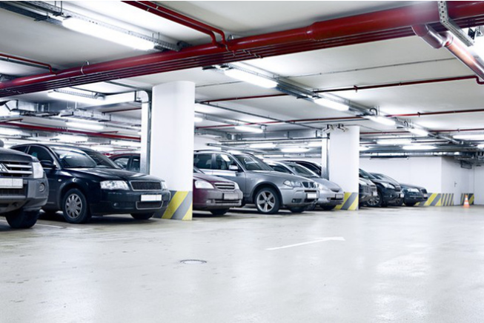

Figure 1: Indoor parking area

Indoor parking areas are growing with the increasing number of vehicles in a developing economy and causing many problems due to multiple floors, followed by zones, distributed parking lots and absence of parking guidance to vehicles drivers. The traditional method of having to navigate around searching for an empty parking lot causes many troubles for drivers, as well as traffic jam in parking areas.

### Outdoor parking area

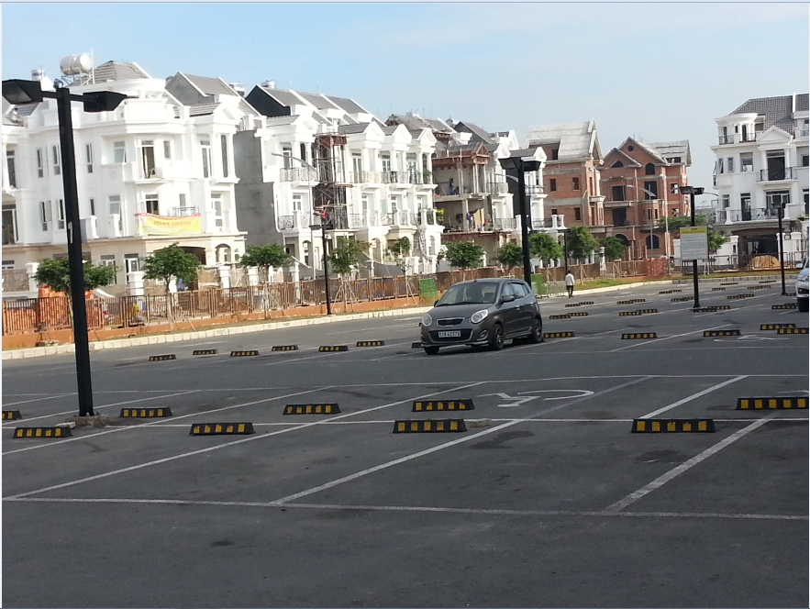

Figure 4: Outdoor parking area

With the increasing number of vehicles, it create lots of issues to build a parking building, or a basement plus some other kind of building on top, especially cost and planning structure. There is no other way except to utilize outdoor spaces of places like public parks, mall, hospital… as an outdoor parking areas.

### Traditional PGS

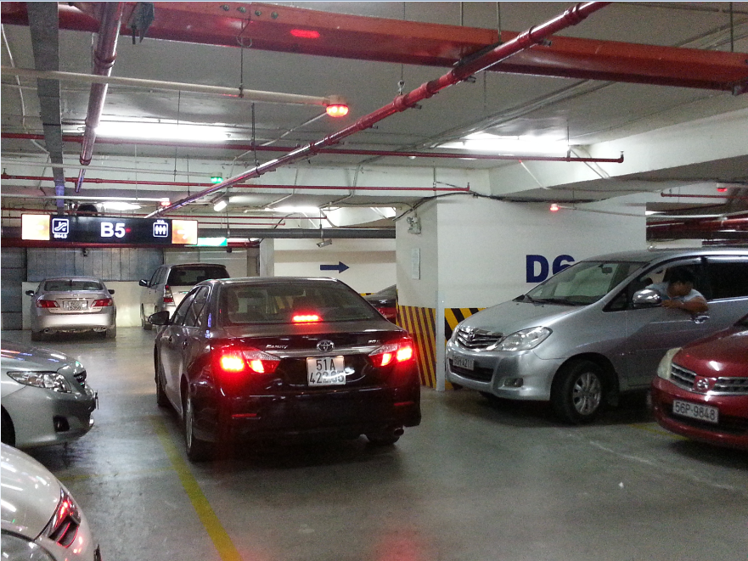

Figure 2: Parking area with PGS

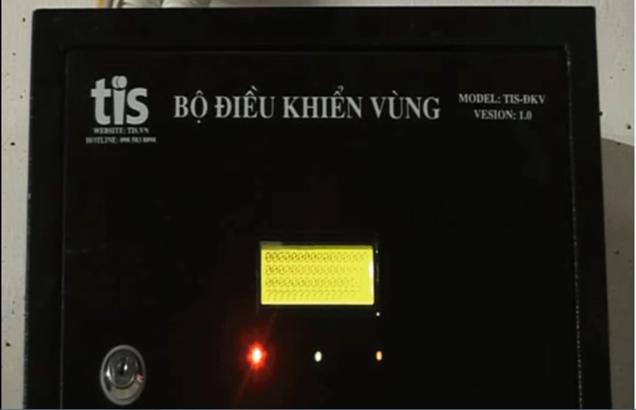

Figure 3: Zone Control Unit

As opposed to the traditional parking areas, the parking areas with PGS keep parking lots under systematic realtime monitoring so as drivers can see what parking spaces are available immediately and with minimal effort. By implementing this, operators also have the chance of increasing their revenues because of the increasing number of satisfied drivers.

The current version of PGS that implemented in a large number parking areas in Vietnam made use of RS485. Each parking lot is fitted with an ultrasonic detector and Indicator light, hence information displays at main entrance and at internal junction points are driven with realtime occupancy detected by ultrasonic detectors. All status sent to a Zone Control Unit on RS485, which in turn be sent to the Central Control Unit.

## Problem Definition

The current version of PGS is working well but it still has some disadvantages:

* The system implements the RS485 so each Zone Control Unit can have maximum 8 loops of 32 Detectors hence supporting 256 parking lots with 8 Information LED Displays. This is fine for most of the current parking areas, but it provides complicated in a parking area with large number of parking lots like the 6 multi-storey car parks with around 7000 parking lots each proposed by Ho Chi Minh City Transport Department.
* The Zone Control Units need to be wired with Detectors, Indicator LED, Information LED Displays and Central Control Unit hence the wiring is pretty complicated and need careful planning in the construction stage. Therefore the current version of PGS is hard to implement in most of the existed parking areas.
* The current version of PGS is difficult to use for outdoor parking areas because of the need of installation of the frame.
* Drivers can only get the information of available parking lots at the entrance of parking areas, so the issues of high proportion of traffic generated by drivers seeking vacant parking lots still remains.

## Proposed Solution

The current version of PGS contains many flaws and proved to be unacceptable for a greater business. Therefore, our proposed solution is to build a parking guidance system with RF modules. The RF modules provide wireless communication directly between Central Control Unit and Detectors, Indicator LED, Information LED Displays so there is no need for the Zone Control Units.

### Feature functions

#### Parking Guidance System

* Detectors sends out ultrasonic signals from the bottom upward and transmits the signals to the guidance units through RF.
* The Indicator LED, Information LED Displays also use RF communication so they are easier to install.
* The Central Control Unit connect with data stream network to provide realtime informations to the app.

#### Mobile app

* Management portal for operators to setup and manage theirs parking area.
* Customer portal where drivers can view on maps the realtime informations of nearby parking areas or search for one.

### Advantages

* Fast orientation of drivers when seeking vacant parking lots
* Minimizing the time needed for finding a vacant parking lot
* Improvement of safety, the increase of the traffic effectiveness and efficiency
* Decreases of exhaust fumes as well as the negative impact of traffic on the environment
* Maximum use of the entire car park capacity
* Easy to assemble

### Disadvantages

* System does not provide car find feature
* The detector can only detect at the location above it so it can’t detect if there is anything around the corner of parking lot
* Management portal does not have web version

## Functional Requirements

Function requirements of the system are listed as below:

* Detector component:
  + Sensor (ultrasonic, infared, magnetic field, load…)
  + RF communication
* Indicator LED component:
  + RGB led controller
  + RF communication
* Information LED Displays component:
  + Main entrance LED Display
  + Internal junction points LED Display
  + RF communication
* Reservation Barrier component:
  + Servo motor controller
  + RF communication
* Central Control System component:
  + Data Stream Network
  + Web API communication
  + RF communication
* Management portal app component:
  + Parking Area Setup
  + Parking Area Analysis
  + Parking Lot Control
* Customer portal app component:
  + Parking Areas Search
  + Parking Lot Reservation
* Web API component:
  + Parking Areas Search
  + Parking Area Setup
  + Parking Area Analysis
  + Parking Lot Status

## Roles and Responsibilities

| **No** | **Full name** | **Role** | **Position** | **Contact** |
| --- | --- | --- | --- | --- |
| 1 | Nguyễn Đức Lợi | Project manager | Supervisor | loind@fpt.edu.vn |
| 2 | Trần Nguyễn Minh Trung | Developer | Leader | trungtnmse61496@fpt.edu.vn |
| 3 | Bùi Phú Hiệp | Developer | Member | hiepbpse61438@fpt.edu.vn |
| 4 | Nguyễn Đỗ Phương Huy | Developer | Member | huyndpse61358@fpt.edu.vn |

Table 2: Roles and Responsibilities

## Conclusion

For this project, we will try to to reproduce the traditional Parking Guidance System with wireless technology, add a web server to manage information, a mobile app to provide UI for normal users and parking area operators to make this more like an IoT application. Therefore, we will need to:

* Research to determine and implement the appropriate MCU for the Central Control Unit and other nodes (Arduino, Raspberry…)
* Research to determine and implement the appropriate sensor for the Detector (ultrasonic sensor, infared sensor, magnet field sensor, load sensor…)
* Research to determine and implement the appropriate RF value and module to provide communication between nodes for the project (315Mhz, 433Mhz, 2.4Ghz…)
* Research and implement LED rgb, seven-segment LED
* Research and implement realtime communication channel
* Research and host Web API on a cloud service
* Study and develop a mobile application (Android, iOS, Windows phone…)
* Study and develop program using embedded language (Arduino, C, C++,…)
* Study and create a Web API (Spring MVC, ASP.NET, Ruby…)
* Study and create a database (SQL, Oracle, MySQL,…)